**FERTILIZER RECOMMENDATION SYSTEM FOR DISEASE PREDICTION USING ARTIFICIAL INTELLIGENCE**

**PROPOSED SOLUTION**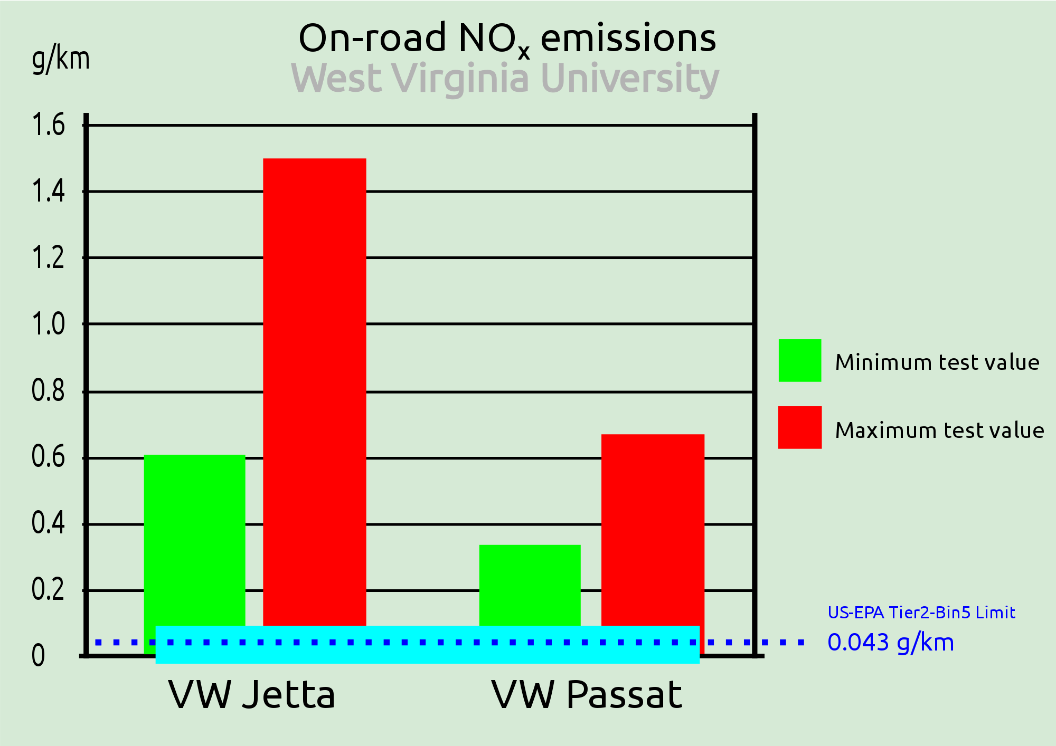

**The aim of the proposed system is to help farmers to cultivate crops for better yield. The crops selected in this work are based on important crops from selected locations. The selected crops are Rice, Jowar, Wheat, Soyabean, and Sunflower, Cotton, Sugarcane, Tobacco, Onion, Dry Chili etc. The dataset of crop yield is collected from the last 5 years from different sources. There are 3 steps in proposed work.**

**1) Soil Classification: Soil classification can be done using soil nutrients data. Two Machine learning algorithms used for soil classification are Random Forest and Support Vector Machine. The two algorithms will classify, and display confusion matrix, Precision, Recall, f1-score and average values, and at the end accuracy in percentage as output.**

**2) Crop Yield Prediction: Crop Yield Prediction can be done using crop yield data, nutrients and location data. These inputs are passed to Random Forest and Support Vector Machine algorithms. These algorithms will predict crops based on present inputs.**

**3) Fertilizer Recommendation: Fertilizer Recommendation can be done using fertilizer data, crop and location data. In this part suitable crops and required fertilizer for each crop is recommended.**

**Third Party applications are used to display Weather information, Temperature information as well as Humidity, Atmospheric Pressure and overall description.**